Matthew Tran
Public-Key Cryptography with RSA
In this lab, I gained hands on experience implementing the RSA public key cryptosystem using C and the OpenSSL Big Number library. RSA is foundational to modern secure communication, enabling encryption, decryption, and digital signatures through mathematical operations on large prime numbers. I learned how to generate keys, encrypt and decrypt messages, sign data, and verify signatures, all while working with numbers far larger than standard data types can handle.

Tools Used
- C Programming Language
- OpenSSL Big Number Library
- Ubuntu
- GCC Compiler

Skills Gained
- Working with arbitrary precision arithmetic
- Implementing RSA key generation, encryption, and decryption
- Generating and verifying digital signatures
- Understanding cryptographic integrity and the avalanche effect

Task 1 Big Number Arithmetic Operations
- Created task1.c and included necessary headers (stdio.h, openssl/bn.h).
- Generated a 256 bit random prime for a, assigned a large decimal value to b, and generated a 256 bit random number for n.
- Computed:
a * b
a^b mod n
- Used a custom function printBN_dec() to print results in decimal format.
- Compiled with: gcc task1.c lcrypto o task1
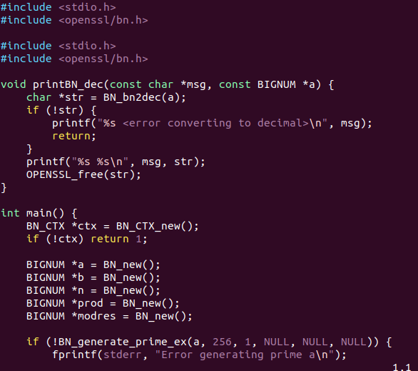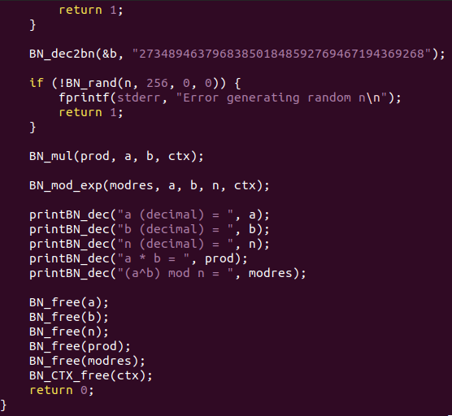
Output :
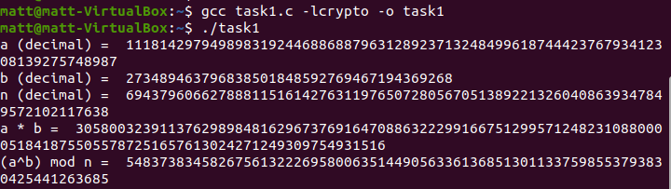
A and n are randomly generated, so each run will produce different results. The output shows that OpenSSL’s Bignum can handle extremely large multiplication and modular operations correctly.
Task 2 RSA Private Key Derivation
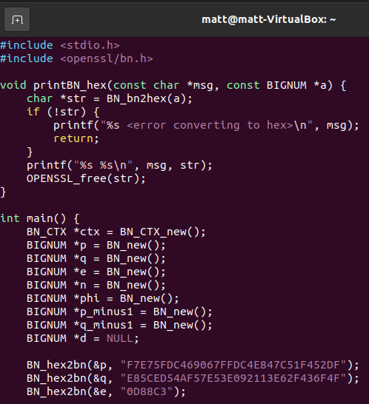
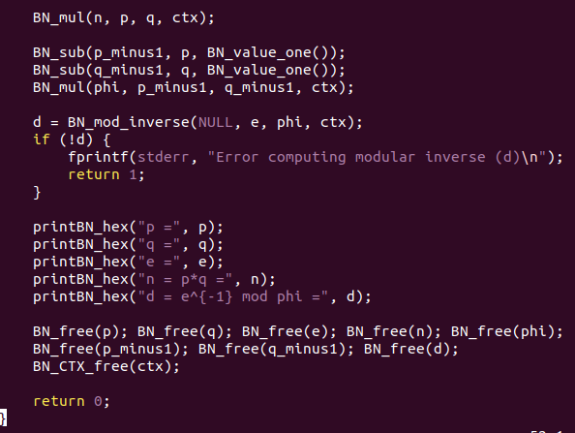
- Created task2.c and included OpenSSL headers.
- Assigned given hexadecimal values to p, q, and e.
- Computed:
n = p * q
phi(n) = (p 1)*(q 1)
d = e^( 1) mod phi(n)

- Printed results in hexadecimal using printBN_hex().
Output: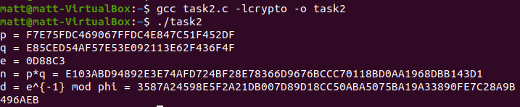
The computed n and d represent the RA modulus and private exponent. The value of d i the modular inverse of e with respect to phi(n), completing the key generation step.

Task 3 RSA Message Encryption
- Created task3.c and converted the message "A top secret!" to hex using Python.
- Loaded the given public key (n, e) and plaintext M as BIGNUMs.
- Encrypted using: C = M^e mod n
- Printed ciphertext in hex.
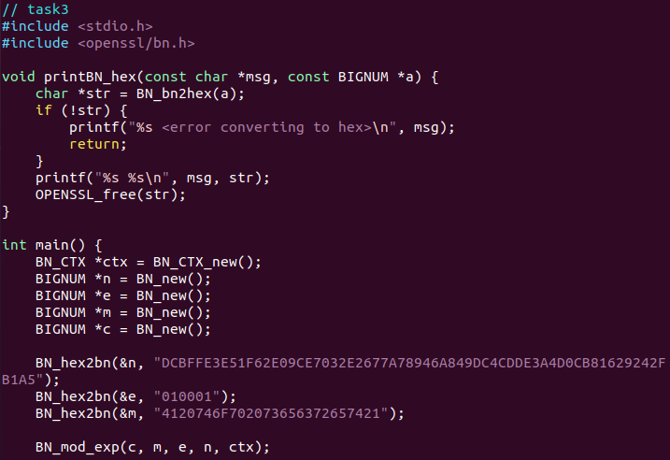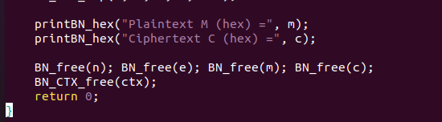

Output:
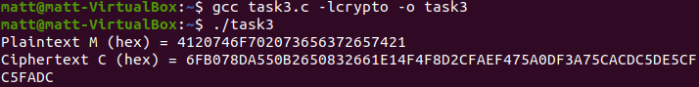
The ciphertext is the encrypted form of the original message created using the public key.
Task 4 RSA Message Decryption
- Created task4.c and loaded the given n, d, and ciphertext C.
- Decrypted using:
- M = C^d mod n
- Printed the decrypted hex and converted it to ASCII using Python.
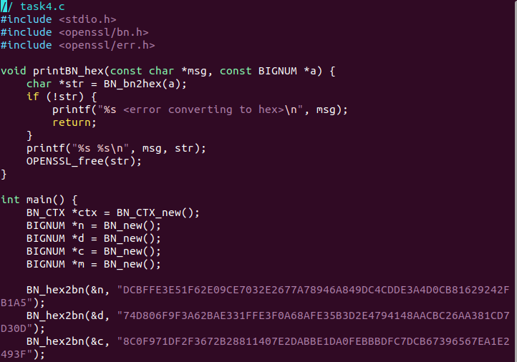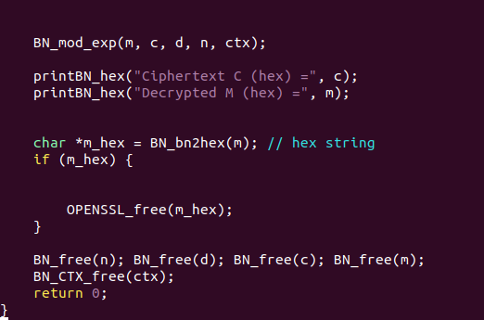
Output:
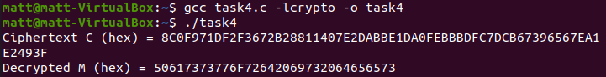
The decrypted message shows a successful recovery of the plaintext. The output verifies the correct uses of modular exponentiation with eh private key.

Task 5 Digital Signature Generation
- Created task5.c with a helper function bn_from_ascii() to convert strings to BIGNUMs.
- Signed two messages:
"I owe you $2000."
"I owe you $3000."
- Used private key d to compute:
S = M^d mod n

- Printed both signatures.
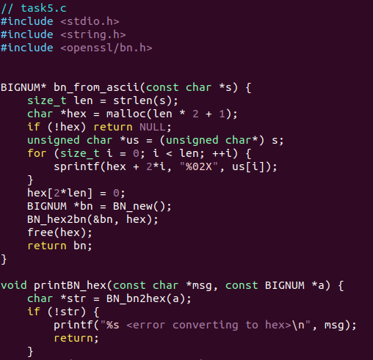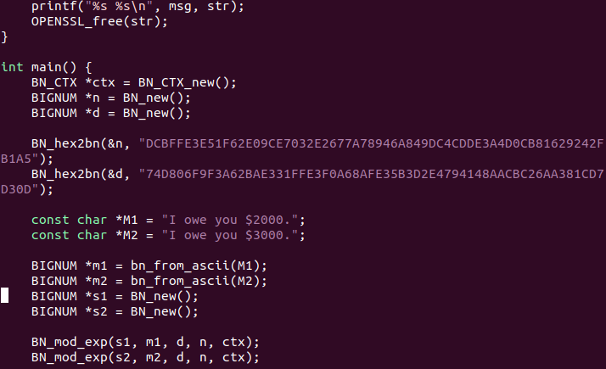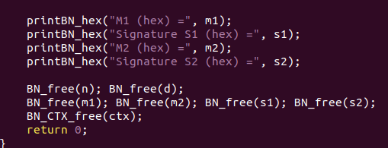
Output:
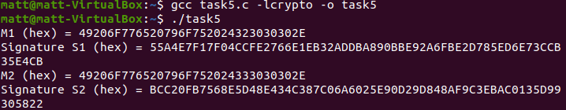
When there is a small change in the message, the results show me a different signature. This is probably showing the avalanche effect in cryptographic signatures when changing a small minor detail can change the outputs vastly. This ensures that the signature will always have a uniqueness and reinforce its security.

Task 6 Digital Signature Verification

- Created task6.c with the same bn_from_ascii() helper.
- Loaded given n, e, and signature S.
- Verified by computing: M' = S^e mod n
- Compared M' with expected message M.
- Repeated with a corrupted signature (last byte changed from 2F to 3F).
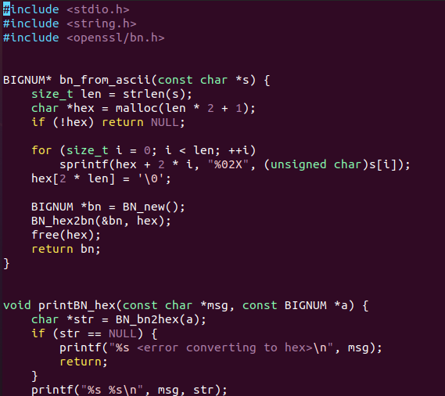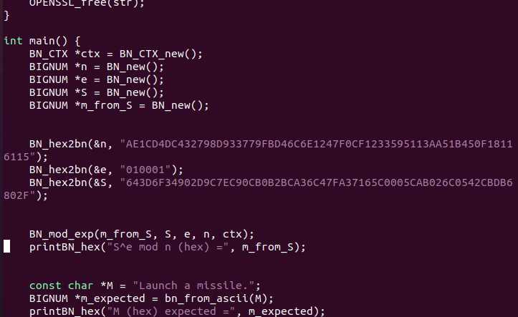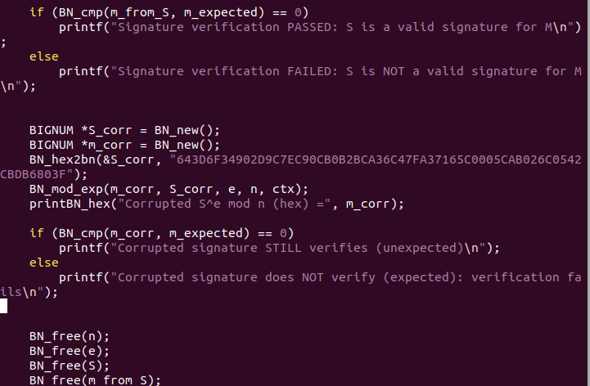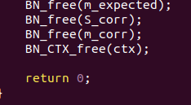
Output:
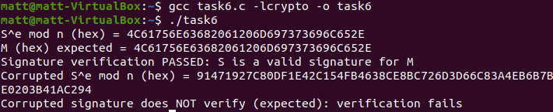
The good signature verifies successfully (M' matches M), while the corrupted signature (one bit changed) fails verification. This shows that digital signatures are extremely responsive to any modification. Even a single bit of change makes the signature invalid.

